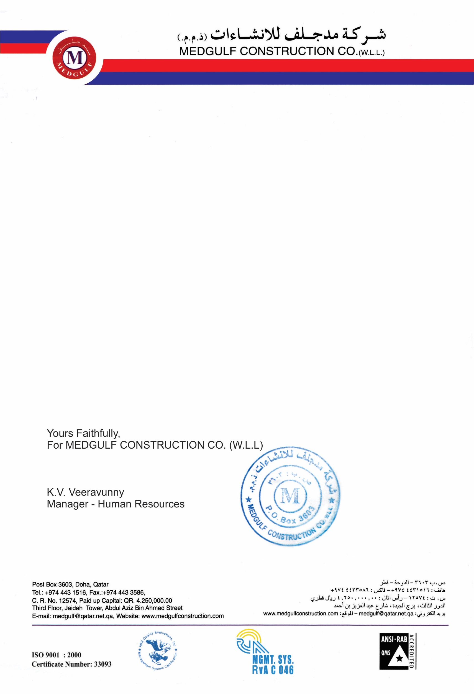

Ref : HR/12096/TER

Date : <To>

**EXPERIENCE CERTIFICATE**

PROJECT : MEDGULF CONSTRUCTION

TERM : <From> To <To>

NAME : <Name>

TRADE : <Designation>

It was confirmed that this guy has worked properly for completion of the MED GULF CONSTRUCTION.

